## A REPORT

## ON

**AUTOMATION IN PAYROLL SYSTEM -Enhancing Efficiency And Accuracy With Technology**

**Submitted by,**

**KRUTHIKA K - 20211CITO1O5**

### Under the guidance of,

**Mr. Tanveer Ahmed**

**Assistant Professor**

**in partial fulfillment for the award of the degree of**

**BACHELOR OF TECHNOLOGY**

**IN**

**COMPUTER SCIENCE AND ENGINEERING (INTERNET OF THINGS)**

**At**



**PRESIDENCY UNIVERSITY**

**BENGALURU**

**MAY 2025**

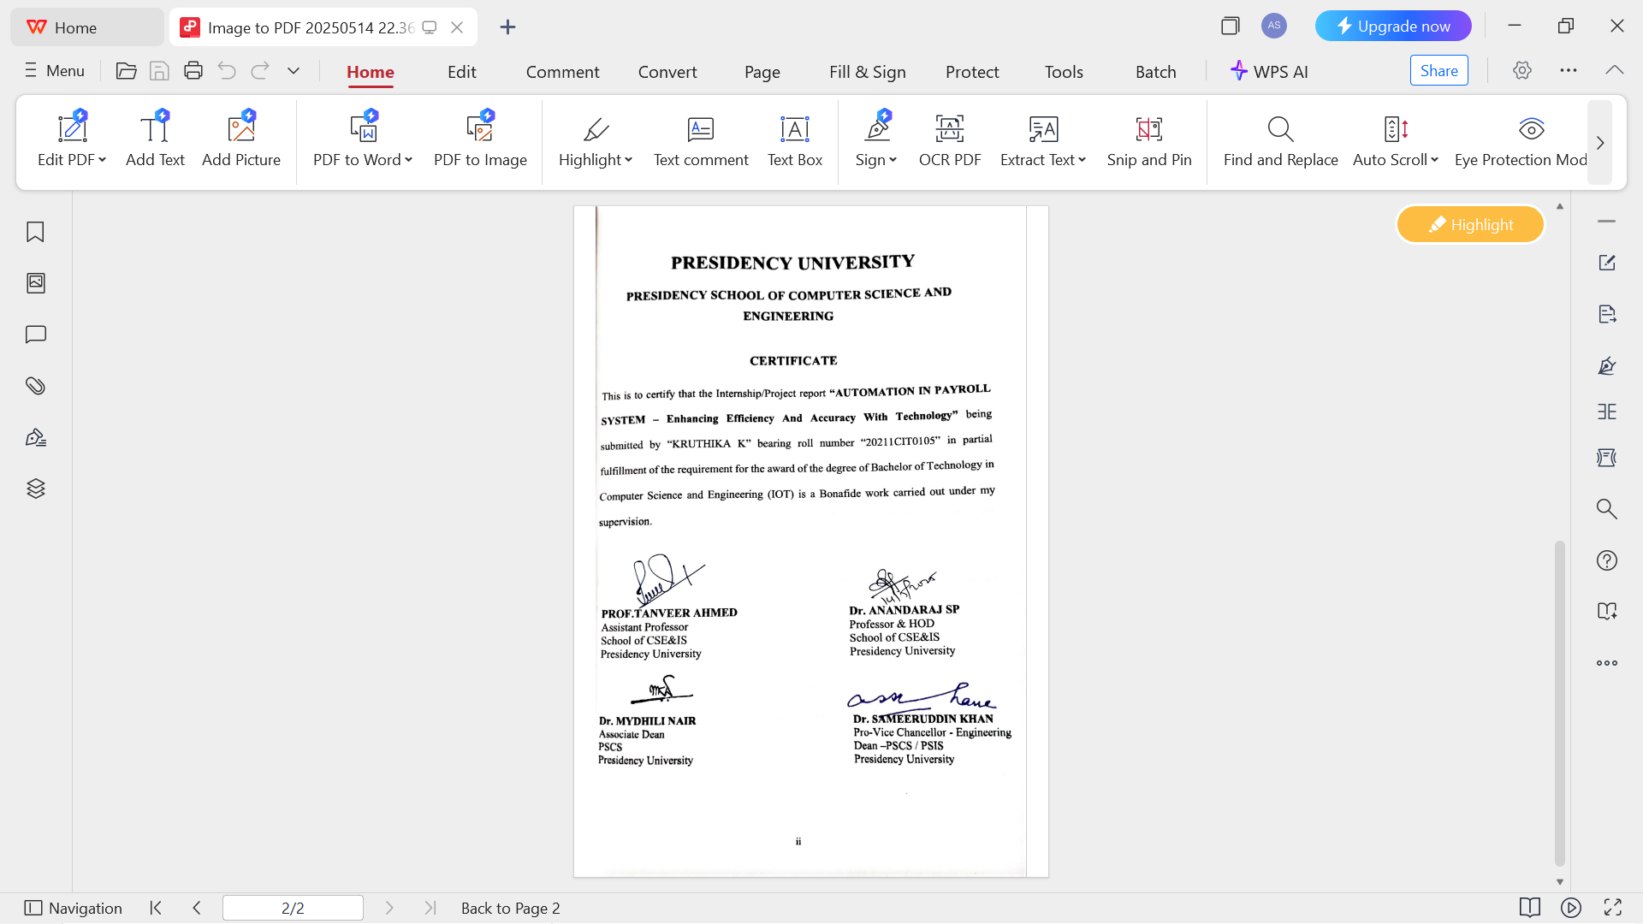

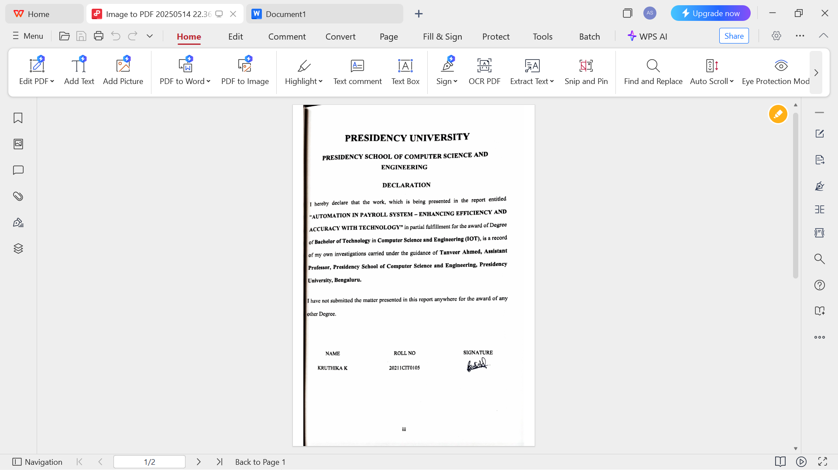

**INTERNSHIP COMPLETION CERTIFICATE**

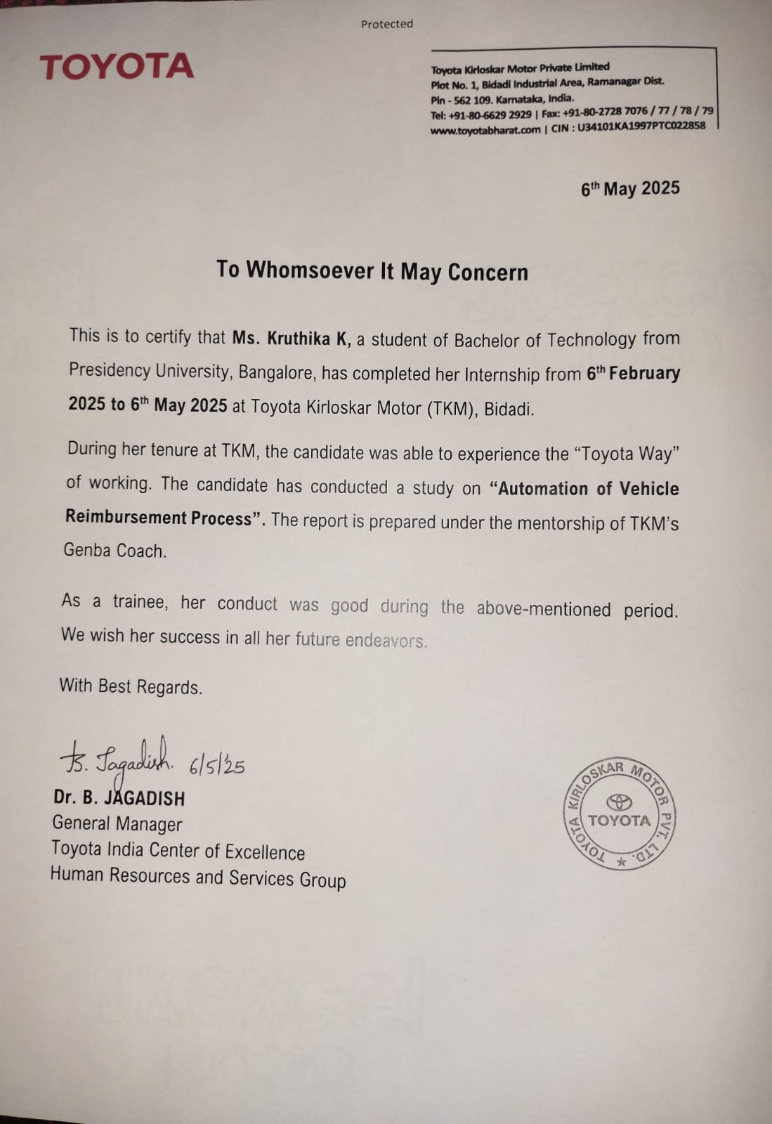

**ABSTRACT**

In today’s digital era, automation plays a critical role in streamlining and enhancing organizational processes. This project, “Automation in Payroll System – Enhancing Efficiency and Accuracy with Technology”, is designed to simplify and optimize employee services at Toyota Kirloskar Motor Pvt. Ltd. through the integration of multiple essential HR functionalities into a single web-based application. The system facilitates secure login for employees and provides access to a company-style dashboard featuring modules such as Salary Slips, Attendance, Vehicle Reimbursement, Profile, and Settings. The Salary Slips section enables employees to view and download their Pay slips, Bonus Slips, and Form 16 documents. The Attendance module allows users to view their monthly attendance records by selecting specific month and year. A major highlight of this project is the Vehicle Reimbursement module, which automates bill verification by extracting key details from uploaded documents and cross-verifying them with organizational data, thus reducing manual workload for HR.

Developed using HTML, CSS, and JavaScript for the frontend, and Flask with SQLite/Excel for the backend, the application also features OTP-based authentication using SMTP for enhanced security. The interface is responsive and user-friendly, simulating a professional corporate environment. By automating core HR functions and ensuring secure document handling, this system not only reduces manual efforts but also improves the overall transparency and accessibility of employee information. This project demonstrates the effectiveness of integrating multiple HR services into a single platform, serving as a scalable foundation for further digital transformation in workplace operations**.**

Keywords: Payroll Automation, Employee Self-Service, Web-Based Dashboard, Payslip Generation, Vehicle Reimbursement Verification, Attendance Management, Flask Backend OTP Authentication, HR Process Optimization, Document Management System.

**ACKNOWLEDGEMENTS**

First of all, we indebted to the **GOD ALMIGHTY** for giving me an opportunity to excel in our efforts to complete this project on time.

We express our sincere thanks to our respected dean **Dr. Md. Sameeruddin Khan**, Pro-VC - Engineering and Dean, Presidency School of Computer Science and Engineering & Presidency School of Information Science, Presidency University for getting us permission to undergo the project.

We express our heartfelt gratitude to our beloved Associate Dean **Dr. Mydhili Nair,** Presidency School of Computer Science and Engineering, Presidency University, and “**Dr. Anandaraj S P**”, Head of the Department, Presidency School of Computer Science and Engineering, Presidency University, for rendering timely help in completing this project successfully.

We are greatly indebted to our guide & Reviewer **Tanveer Ahmed, Assistant Professor**, Presidency School of Computer Science and Engineering, Presidency University for her inspirational guidance, and valuable suggestions and for providing us a chance to express our technical capabilities in every respect for the completion of the internship work.

We would like to convey our gratitude and heartfelt thanks to the PIP4001 Internship/University Project Coordinator **Mr. Md Ziaur Rahman and Dr. Sampath A K,** department Project Coordinators “**Dr. Sharmasth Vali**” and Git hub coordinator **Mr. Muthuraj.**

We thank our family and friends for the strong support and inspiration they have provided us in bringing out this project.

**Kruthika K**

**LIST OF TABLES**

|  |  |  |  |
| --- | --- | --- | --- |
| **Sl. No.** | **Table Name** | **Table Caption** | **Page No.** |
| 1 | Table 1.1.3 | Overview of P1 & P2 | 4 |
| 2 | Table 2.3 | Study of existing tools/technology/methods | 10-11 |
| 3 | Table 9.1 | OVERALL IMPACT | 40 |

**LIST OF FIGURES**

|  |  |  |  |
| --- | --- | --- | --- |
| **Sl. No.** | **Figure Name** | **Caption** | **Page No.** |
| 1 | Figure 1 | FIG 1 | 2 |
| 2 | Figure 2 | FIG 2 | 2 |
| 3 | Figure 4.1 | System Architecture – Front End | 17 |
| 4 | Figure 4.2 | System Architecture – Back End | 18 |
| 5 | Figure 6.1 | Front-End flowchart | 26 |
| 6 | Figure 6.2 | Back-End flowchart | 28 |
| 7 | Figure 3 | Database.py | 45 |
| 8 | Figure 4 | Vehicle bill detail storage | 46 |
| 9 | Figure 5 | Employee database | 46 |
| 10 | Figure 6 | Login page | 47 |
| 11 | Figure 7 | Salary slips page | 47 |
| 12 | Figure 8 | Attendance view page | 48 |
| 13 | Figure 9 | Upload bills(Vehicle reimbursement) | 48 |

**TABLE OF CONTENTS**

|  |  |  |
| --- | --- | --- |
| **CHAPTER NO.** | **TITLE** | **PAGE NO.** |
|  | **ABSTRACT ACKNOWLEDGMENT** | **I**  **ii** |
| **1.** | **INTRODUCTION** | 1 |
|  | 1.1 ABOUT THE COMPANY | 1-5 |
|  | 1.2 MOTIVATION OF THE PROJECT: | 5 |
|  | 1.3 PROBLEM STATEMENT | 6 |
|  | 1.4 OBJECTIVES | 6-7 |
|  | 1.5 SCOPE OF THE PROJECT | 7-8 |
| **2.** | **LITERATURE REVIEW** | 9 |
|  | 2.1 INTRODUCTION | 9 |
|  | 2.2 RELATED WORK | 9-11 |
|  | 2.3 EXISTING WORD | 11-12 |
|  | 2.4 SUMMARY | 12-13 |
| **3.** | **RESEARCH GAPS OF EXISTING METHODS** | 14-17 |
| **4.** | **PROPOSED METHODOLOGY** | 18-23 |
| **5.** | **OBJECTIVES** | 24-27 |
| **6.** | **SYSTEM DESIGN & IMPLEMENTATION** | 28-29 |
|  | 6.1 INTRODUCTION | 29-30 |
|  | 6.2 SYSTEM COMPONENTS | 30-31 |
|  | 6.3 WORKFLOW OVERVIEW | 31 |
|  | 6.4 FLOWCHARTS AND DIAGRAMS | 31 |
|  | 6.5 IMPLEMENTATION STEPS | 31-32 |
|  | 6.6 SECURITY CONSIDERATIONS | 32 |
|  | 6.7FUTURE ENHANCEMENTS | 32 |
| **7.** | **TIMELINE FOR EXECUTION OF PROJECT(GANTT CHART)** | 33 |
| **8.** | **OUTCOMES** | 34-37 |
| **9.** | **RESULTS AND DISCUSSIONS** | 38-42 |
| **10.** | **CONCLUSION** | 43 |
| **11.** | **REFERENCES** | 44 |
| **12.** | **APPENDIX-A** | 45-48 |
| **13.** | **APPENDIX-B** | 48-49 |
| **14.** | **APPENDIX-C** | 51-52 |

**Chapter 1**

**INTRODUCTION**

In today’s digital age, the efficiency of HR operations has a significant impact on overall organizational productivity. The traditional methods of document distribution, such as issuing hard copies of payslips and tax forms or responding to individual employee requests, are not only time-consuming but also prone to delays and confidentiality breaches.

With automation becoming a cornerstone of modern business practices, HR departments are actively transitioning toward digital tools that offer real-time access, secure document handling, and simplified workflows. This report describes the end-to-end development of a **Web-Based Employee Document Automation and Reimbursement System** undertaken as part of my internship at **Toyota Kirloskar Motor Pvt. Ltd.**

The project aims to simplify the process of distributing sensitive HR documents—such as payslips, bonus forms, and Form 16—while also enabling employees to upload and manage vehicle reimbursement claims.

* 1. **ABOUT THE COMPANY:**

**1.1.1COMPANY HISTORY:**

The history of Toyota started in 1933 with the company being a division of Toyoda Automatic Loom Works devoted to the production of cars under the direction of the founder's son, Kiichiro Toyoda. Kiichiro Toyoda had traveled to Europe and the United States in 1929 to investigate automobile production and had begun researching gasoline-powered engines in 1930. Toyoda Automatic Loom Works was encouraged to develop automobile production by the Japanese government, A person wearing glasses and a suit
which needed domestic vehicle production, due to the war with China. Kiichiro Toyoda seized this opportunity to establish the Automotive Production Division on September 1, 1933, and began preparing to build prototype vehicles. In 1934, the division produced its first Type A Engine, which was used in the first Model A1 passenger car in May 1935 and the G1 truck in

**FIG 1** August 1935. Production of the Model AA passenger car started in 1936. Early vehicles bear a striking resemblance to the Dodge Power Wagon and 1930's Chevrolet, with some parts actually interchanging with their American originals. Although the Toyota Group is best known today for its cars, it is still in the textile business and still makes automatic looms, which are now computerized, and electric sewing machines which are available worldwide.

**Toyota logo from 1935 to 2025**

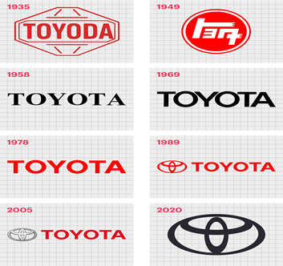The Toyota emblem is a combination of three overlapping that symbolize the unification of Toyota customers hearts and the heart of Toyota products.  The current Toyota logo consists of two perpendicular ovals inside the bigger and outer oval symbolizing the letter “T” for Toyota the steering wheel in the logo represents the vehicle, and the outer oval represents the world’s embracing Toyota. The “T” shape formed by the perpendicular interior ovals founder, Kiichiro Toyoda.

**FIG 2**

**1.1.2 TOYOTA PRINCIPLES AND KEY VALUES:**

The foundation of Toyota’s global success lies in the **Toyota Way**, which integrates two core philosophies: **continuous improvement** (*Kaizen*) and **respect for people**. These principles are deeply embedded in Toyota's corporate culture and serve as guiding values for decision-making, process design, and team collaboration.

**A. Toyota Way – Guiding Principles**

Toyota emphasizes a structured approach toward problem-solving, innovation, and sustainable growth. The guiding principles include:

* The right process will produce the right results.
* Create continuous flow to expose and address problems.
* Use the pull system (Just-in-Time) to prevent overproduction.
* Level the workload (*Heijunka*) to avoid bottlenecks.
* Avoid passing defective products downstream.
* Take only what is needed and produce exactly what is required.
* Fine-tune and stabilized production processes.
* Encourage employees by challenging them and supporting improvement.
* Genchi Genbutsu – Go to the source to understand the real situation.
* Decide slowly by consensus, consider all options, and implement quickly.
* Become a learning organization through relentless innovation.

**B. Toyota’s Core Values**

The company’s values are designed to foster trust, growth, and integrity at all organizational levels. These values reflect Toyota’s belief in individual empowerment and community collaboration.

* Act for others – Work in service of the team and society.
* Work with integrity – Honesty and responsibility are non-negotiable.
* Drive curiosity – Encourage innovation through questioning and learning.
* Get better and better – Strive for continuous self and process improvement.
* Continue the quest – Never stop seeking new and better ways.
* Create room to grow – Enable personal and professional development.
* Welcome competition – Learn from and outperform the best.
* Show respect – Value every individual and their contributions.
* Thank people – Appreciate effort and support.

In India, TMC established Toyota Kirloskar Motor Private Ltd. (TKM) as a joint venture with Kirloskar Group in 1997 and began local production.

* TKM is a joint venture between Toyota Motor Corporation and the Kirloskar Group.
* The plant is located in the Bidadi Industrial area, on the outskirts of Bengaluru.
* The plant manufactures a variety of vehicles, including the Innova Hycross, Innova Crysta, Fortuner, and Legender.
* In May 2023, TKM announced that it would begin three-shift operations at the plant to increase Production.
* TKM also has a technical education facility in Bidadi called the Toyota Technical training Institute (TTTI).

**1.1.3 OVERVIEW OF TKM**

Company name:                                   Toyota Kirloskar Motor Pvt Ltd.

Equity participation TMC:                  89%, Kirloskar systems limited 11%.

Number of employees:                         Approximately 6,500

Land area:                                            Approximately 432 acres

Building area:                                       74000 m2

Total installed production capacity:     Up to 3,10,000 units

**Overview of plant 01 & plant 02:**

|  |  |  |
| --- | --- | --- |
| Basis | Plant 1 | Plant 2 |
| Established on | October 1997 | December 2010 |
| Products | Innova, Fortuner, manufactured | Toyota Yaris, Etios, Etios liva, Camry & Camry Hybrid |
| Installed production Capacity | Up to 1,00,000 Units | 2,10,000 Units |
|  |  |  |

**TABLE 1.1.3 – Overview of P1 & P2**

**1.1.4 Toyota Production System (TPS)**

The **Toyota Production System (TPS)** is a globally renowned manufacturing methodology focused on the elimination of waste and achieving maximum efficiency. Often associated with **lean manufacturing** and **Just-in-Time (JIT)** production, TPS ensures that only what is needed is produced, when it is needed, and in the exact quantity required.

TPS is built on two foundational pillars:

* **Jidoka** – Automation with a human touch: If a problem occurs, the machinery stops automatically to prevent defective products.
* **Just-in-Time (JIT)** – Producing only what is needed for the next process in a continuous and efficient flow.

TPS not only supports high-quality vehicle production but also contributes to Toyota's competitive advantage through cost reduction and operational flexibility. The system reflects Toyota’s long-standing culture of continuous improvement (kaizen) and customer satisfaction.

Within TPS, **Jidoka** plays a critical role in ensuring safety, quality, and efficiency. At Toyota, Jidoka means stopping the production line whenever an abnormality is detected, allowing immediate investigation and resolution. This concept is not just about machines, it is about embedding human intelligence into automation.

Initially, new production lines are assembled manually by engineers to ensure precision and safety. Through **incremental kaizen**, the processes are simplified until consistent results can be achieved by any operator. Once the line is stable and efficient, the **Jidoka mechanism** is incorporated.

This process helps reduce costs, simplify machinery, and enhances maintainability. More importantly, it nurtures **engineering skill and craftsmanship**, ensuring machines evolve through human learning and not automation alone.

By continuously improving both human skills and technology, TPS strengthens Toyota’s manufacturing excellence and its ability to deliver ever-better cars. The emphasis on developing self-reliant individuals who can innovate and implement kaizen is fundamental to Toyota’s long-term success.

* 1. **MOTIVATION OF THE PROJECT:**

At a large organization like Toyota Kirloskar Motor Pvt. Ltd., smooth internal communication and efficient HR operations play a crucial role in keeping employees satisfied and the organization running effectively. One area that continually calls for improvement is how payroll documents are shared and how payment-related claims are managed.

Currently, employees who don’t have access to internal ERP systems like Oracle often face hurdles just to get basic documents like monthly payslips, Form 16, or bonus slips. They have to depend on the HR team for each request. Similarly, submitting reimbursement claims—whether for fuel, tolls, or other expenses—can be a tedious, manual task involving physical receipts, long email chains, and a lot of back-and-forth. This not only slows things down but also adds extra pressure on HR, increases the chances of mistakes, and limits visibility for employees over the status of their claims.

Driven by Toyota’s commitment to Kaizen (continuous improvement) and Digital Transformation, this project was initiated to address these pain points and bring in real, meaningful change. Our goals are simple but impactful:

* Give employees easy, self-service access to their documents anytime, anywhere
* Streamline the reimbursement process by automating claim submissions and approvals
* Maintain strict data privacy and controlled access to sensitive information
* Lighten the administrative load on HR so they can focus on more strategic task
* Support Toyota’s vision of a greener, paperless workplace

With the development of a secure, centralized, and user-friendly employee portal, we’re aiming to not only boost efficiency but also deliver a better, more transparent experience for every employee. This is more than just a tech upgrade—it’s a step forward in living Toyota’s core values and fostering a culture of innovation and continuous improvement..

* 1. **PROBLEM STATEMENT:**

Although Toyota Kirloskar Motor Pvt. Ltd. has a well-established ERP system, not all employees have access to retrieve their HR-related documents independently. As a result, the HR department receives a high volume of repetitive requests for:

* Monthly payslips
* Yearly Form 16 (tax documentation)
* Bonus slips and other payroll forms

This manual document distribution process leads to several challenges:

1. Delay in Response: Employees must wait for HR to manually search, validate, and email their documents.
2. Loss of Confidentiality: Sharing sensitive financial data over email or through shared drives poses a security risk.
3. Increased HR Workload: A large chunk of HR resources are spent on tasks that could be easily automated.
4. Limited Accessibility: Employees cannot retrieve older documents without reaching out to HR, which leads to frustration.
5. Reimbursement Complexity: Submitting and validating reimbursement bills (fuel, maintenance, etc.) involves manual Excel checks, which are prone to error and delay.
6. No Status Transparency: Employees do not receive real-time updates on their reimbursement claim status (pending, approved, rejected).

These issues prompted the need for a comprehensive web-based solution to automate document distribution and verification, improve data access, and enhance employee autonomy.

* 1. **OBJECTIVES:**
* **To develop a secure and responsive web-based dashboard** that allows employees to log in and access various HR-related modules.
* **To automate the distribution of monthly and annual payroll documents**, including payslips, bonus slips, and Form 16.
* **To enable month-wise and year-wise filtering** so that employees can download historical documents at any time.
* **To implement an OTP-based password reset system**, increasing security and reducing dependency on HR for credential recovery.
* **To build a document upload and verification system** for vehicle reimbursements, validating bill amount, date, and number against company records.
* **To design a scalable platform** that can be integrated with existing internal systems like **Toyota Mithra** in the future.
* **To minimize manual HR workload** by digitizing routine document handling and claim verification processes.
  1. **SCOPE OF THE PROJECT:**

This project focuses on the end-to-end design, development, and deployment of a user-friendly, secure Employee Document Access and Reimbursement Portal tailored specifically for the workforce at Toyota Kirloskar Motor Pvt. Ltd.—particularly those without access to internal ERP systems like Oracle.

The portal is designed with the following key features and priorities:

**1. Employee-First Experience**

Built with accessibility in mind for employees who currently lack ERP access.

A personalized dashboard provides easy navigation to payroll documents, reimbursement claims, and other HR essentials—all in one place.

**2. Modular and Future-Ready Architecture**

The system is designed to evolve. Its modular structure allows for seamless expansion into features like performance appraisals, leave management, and benefits enrollment, ensuring long-term value.

**3. Robust Security and Role-Based Access**

Only verified users can log in and view their personal documents.

Multi-layered security includes encrypted passwords and OTP-based authentication, ensuring confidentiality and controlled access.

**4. Device Agnostic and Integration-Friendly**

Fully responsive across desktops, tablets, and mobile browsers.

Built to integrate easily with existing platforms like the Toyota Mithra mobile app for a unified digital experience.

**5. Empowered Self-Service**

Employees can download payslips, Form 16, and bonus slips anytime—without needing HR intervention.

They can also submit reimbursement requests by uploading scanned receipts and monitor the real-time status of their claims (pending, approved, rejected), reducing uncertainty and improving transparency.

This portal will not only reduce administrative overhead but also empower employees with independence and convenience, reflecting Toyota’s commitment to continuous improvement and digital innovation.

**Chapter 2**

**LITERATURE SURVEY**

### ****2.1 Introduction****

## Payroll operation, document distribution, and payment processing are critical factors of HR systems. In numerous associations, these processes are moreover incompletely automated or entirely homemade, leading to inefficiencies, detainments, and data operation issues. As diligence shifts toward digital HR operations, several studies and systems have explored web- grounded and automated results to enhance effectiveness, translucency, and availability in these disciplines. This chapter presents a detailed review of affiliated work, evaluates current systems, and identifies the gaps that led to the development of this design.

**2.2.1 Web-Based Payroll Systems**

Many projects and software solutions have been developed to bring payroll operations online. Most of these platforms provide basic functionality such as user authentication, salary calculation, payslip generation, and report exports. However, limitations remain in terms of scalability, data protection, and integration with broader HR systems.

**K. Kumar et al. (2019) – PHP-Based Payroll Automation System**

This system focused on developing a lightweight payroll management tool using PHP and MySQL. HR staff could use the interface to configure salary structures, process deductions, and generate payslips.

* **Pros:** Modular design for payroll functions; incorporated basic tax deductions.
* **Cons:** Lacked security features such as OTP login; did not include reimbursement or attendance modules; interface not optimized for mobile devices.

**A. Singh & M. Patel (2021) – Salary Portal for Educational Staff**

Tailored for academic institutions, this project introduced a web portal that allowed faculty members to access monthly salary slips, with admin-side tools for salary calculation and PDF export.

* **Pros:** Easy-to-use interface; enabled monthly payslip download.
* **Cons:** Did not include Form 16 or bonus slip support; backend validations were limited to manual Excel input; minimal document encryption measures.

**2.2.2 HR Document Management Systems**

Document Management Systems (DMS) are widely used to digitize employee records such as appointment letters, tax forms, and performance reviews. While they offer centralized access and reduce paper dependency, many lack real-time integration with payroll data and secure document handling workflows.

**B. Joseph (2020) – Cloud-Based DMS with Digital Signatures**

This system integrated with Google Drive to facilitate secure document storage and retrieval. It supported digital signatures and basic access permissions**.**

* **Pros:** Cloud integration; document categorization; digital verification support.
* **Cons:** Did not support dynamic document generation (e.g., payslips on demand); lacked advanced encryption for sensitive files; no filter by document age or type**.**

**Infosys PeopleSoft – Enterprise HR Suite**

A comprehensive ERP tool widely adopted by large enterprises, PeopleSoft includes recruitment, payroll, and documentation modules under one unified system.

* **Pros:** Fully integrated with organizational HR processes; scalable for enterprise environments.
* **Cons:** High cost of deployment; requires extensive training for end users; not viable for department-level rollouts or mid-sized companies.

**2.2.3 Reimbursement Automation Solutions**

Automation of reimbursement processes is an emerging trend aimed at simplifying the submission and approval of expense-related claims. These systems attempt to reduce paperwork, improve tracking, and ensure timely validation.

**S. Rao et al. (2022) – Expense Claim Management Portal**

This project introduced a platform for uploading reimbursement bills such as fuel or toll receipts. Claims were reviewed manually against Excel logs before approval.

* **Pros:** Reduced paper usage; centralized portal for claim submission.
* **Cons:** Still required manual verification; lacked automation of Excel data validation; no live status tracking for claimants.

**Expense Anywhere / Zoho Expense – SaaS Expense Tracking Tools**

These commercial platforms offer end-to-end digital claim management, including mobile receipt capture, approval workflows, and analytics dashboards.

* **Pros:** Optical Character Recognition (OCR) for receipts; mobile app support; analytics and approval workflows.
* **Cons:** Subscription-based models with limited local hosting support; customization constraints; not ideal for companies needing on-premise data storage due to internal data policies**.**

### ****2.3 Existing Work:****

|  |  |  |  |
| --- | --- | --- | --- |
| ****Tool System**** | ****Method**** | ****Advantages**** | ****Limitations**** |
| **Oracle HRMS** | Enterprise-grade ERP with payroll and document workflows | Highly configurable, supports payroll rules, benefits integration | Complex UI, expensive, not accessible to all employees, high training requirement |
| **Tally ERP 9 Payroll** | Local payroll and tax computation with payslip printing | Widely used in India, effective for small businesses | Not web-based, lacks multi-user access, manual document sharing |
| **Zoho Payroll** | Cloud-based SaaS platform for automated payroll, compliance, Form 16 | Offers statutory compliance, form generation, user portal | High recurring cost, less customizable for internal processes, no offline integration |
| **Google Forms + Sheets** | Manual form submission with Drive-based record storage | Easy to implement, no coding needed, accessible through Gmail accounts | No validation, no OTP, not secure for financial records, lacks automation |
| **Excel-Based Templates** | Employee data stored and updated manually in Excel sheets | Easy for small teams, customizable | Error-prone, lacks multi-user access, document handling is manual, no file security or traceability |

**TABLE 2.3: Study of existing tools/technology/methods**

### ****2.4 Summary:****

### While a broad spectrum of tools exists across payroll automation, document management, and reimbursement handling, most available solutions either lack advanced features or are not tailored for internal deployment in highly regulated environments. Key deficiencies include the absence of secure access controls, dynamic document filtering, automated validation mechanisms, and mobile-friendly interfaces.

These gaps underscore the need for a unified, fully integrated platform purpose-built for Toyota Kirloskar Motor Pvt. Ltd., combining multiple HR functions with a strong emphasis on data security and user autonomy.

**The proposed system addresses these limitations by offering:**

* Secure OTP-based login and encrypted password storage
* Downloadable documents with filters by month and year (payslips, bonus slips, Form 16)
* Attendance tracking by date range
* Reimbursement submission with automated backend Excel validation
* A responsive and scalable UI accessible across devices
* This solution aims to empower employees, ease HR workloads, and drive Toyota’s digital transformation journey forward while ensuring compliance, confidentiality, and operational efficiency**.**

**Chapter 3**

**RESEARCH GAPS OF EXISTING METHODS**

Despite the proliferation of enterprise and cloud-based HR solutions, existing methods for payroll automation, document handling, and reimbursement tracking are either too generalized or heavily fragmented. Most available platforms offer limited customizability, poor user experience, and minimal integration with existing company infrastructure.

In large organizations such as **Toyota Kirloskar Motor Pvt. Ltd. (TKM)**, which prioritizes operational efficiency, employee empowerment, and process transparency, the absence of a unified, secure, and automated portal for HR documentation and reimbursement workflows presents a significant bottleneck. This chapter outlines **five critical areas** where current systems fall short, justifying the need for the development of a tailored platform that aligns with Toyota’s operational philosophy.

**3.1 Absence of a Centralized, Employee-Centric Self-Service Portal**

In many organizations, access to payroll and HR documents is restricted to backend systems like Oracle HRMS or SAP. While these platforms offer robust features for HR personnel, they are not designed with the employee as the primary user. As a result, employees must rely on email communication or manual intervention from HR staff to retrieve monthly pay slips, bonus slips, or tax-related documents like Form 16.

In Toyota's context, this becomes particularly inefficient given the size of its workforce and the importance of confidentiality. The lack of a dedicated portal accessible to all employees—regardless of their ERP credentials—leads to:

* Delays in document retrieval
* Increased dependency on HR staff
* Risk of data exposure through non-secure communication channels

Furthermore, without a self-service model, employees are disempowered, and the HR department faces an unnecessary administrative load, ultimately affecting productivity and responsiveness.

Research Gap: There is a significant absence of an integrated, employee-focused web portal that allows for independent access to payroll-related documents and personal records, especially for those who are not active users of Oracle or similar ERP systems.

**3.2 Weak Security Architecture in Existing Document Access Systems**

Confidential documents such as payslips and Form 16 contain sensitive employee data including salary components, PAN numbers, deductions, and bank account details. However, many existing systems fail to implement industry-standard security protocols to protect such data during storage, transmission, and access.

Most platforms rely on simple username-password authentication, which is susceptible to brute-force attacks or credential leaks. In addition:

* Documents may be stored in unsecured directories without encryption.
* Download logs are not maintained, making it impossible to track unauthorized access.
* The absence of OTP-based login or multi-factor authentication leaves the system vulnerable, lacking an additional protective layer to verify user identity.

In the case of TKM, where operational confidentiality and data integrity are vital, such lapses could result in regulatory non-compliance, internal data breaches, or reputational damage.

Research Gap: Existing platforms lack a layered security infrastructure that includes OTP-based authentication, encrypted document delivery, and real-time access logging to ensure compliance and employee data privacy.

**3.3 Reimbursement Verification Processes Are Manual and Non-Scalable**

Reimbursement workflows, especially vehicle-related claims like fuel, toll, and servicing—are typically managed through Excel-based records. Employees scan and submit physical bills, which are manually verified by HR or finance staff against predefined limits or logs. This traditional approach suffers from multiple inefficiencies:

* It is labor-intensive, requiring manual cross-verification of bill number, date, and amount.
* It introduces room for human error, such as missed duplicates, outdated claims, or data mismatches.
* There's a high risk of fraud, as bills can be manipulated without digital watermarking or validation checks.

During peak reimbursement periods, such as quarterly expense cycles or travel reimbursement closures, this manual system becomes unscalable, resulting in backlogs and employee dissatisfaction.

Modern tools like Zoho Expense provide some automation but do not integrate easily with Excel-based datasets used internally in many Indian corporations like Toyota. Additionally, third-party solutions often pose data residency issues or require internet access, which may be restricted within industrial environments.

Research Gap: Existing solutions do not provide automated reimbursement validation workflows that extract data from uploaded bills and intelligently compare it against internal Excel databases, reducing HR burden and improving claim accuracy.

**3.4 Poor Visibility and Real-Time Tracking for Reimbursement and Document Requests**

One of the most frequent complaints from employees in manual HR systems is the lack of transparency in request processing. Whether it is a document download request or a reimbursement submission, users are often left in the dark about the progress of their requests.

Current systems offer no real-time dashboard to display:

* Pending requests
* Rejected claims with reasons
* Estimated timelines for processing
* Download history of critical documents

This lack of feedback not only reduces trust in the system but also leads to repetitive follow-ups, email threads, and manual record checks. For HR teams, this results in a duplication of effort and undermines operational efficiency.

In a company like Toyota, where lean operations are essential, such inefficiencies contradict the philosophy of Jidoka (automation with human touch) and Kaizen (continuous improvement).

Research Gap: Most platforms lack dynamic tracking and status update features for employees to monitor their document requests and reimbursement claims, leading to confusion, dissatisfaction, and administrative overload.

**3.5 Limited Platform Flexibility, Mobile Compatibility, and Integration with In-House Tools**

Many off-the-shelf HR and payroll tools are either cloud-only solutions or highly rigid enterprise applications. These solutions:

* Require costly licensing and implementation
* Do not support on-premises hosting or local network deployment
* Lack APIs for easy integration with in-house tools like Toyota Mithra

•Are not optimized for mobile platforms, despite the increasing use of smartphones by employees on shop floors or during field assignments

At Toyota, the digital infrastructure is thoughtfully constructed around proprietary systems and well-defined organizational protocols. For any HR automation initiative to deliver real value, it must be capable of embedding itself seamlessly within this existing framework. In today’s fast-paced work environment, where many employees are dispersed across locations or operate from the field, mobile accessibility is not a feature—it's a fundamental requirement.

Research Gap: Existing tools are not designed for easy integration with internal Toyota systems or mobile-friendly environments, making them impractical for flexible and scalable deployment within the company’s infrastructure.

**Chapter 4**

**PROPOSED MOTHODOLOGY**

The **Employee Payroll Management System** for **Toyota Kirloskar Motor Pvt. Ltd.** is designed to streamline payroll access, enhance document security, reduce HR workload, and empower employees with a self-service platform. Built using modern, lightweight, and scalable technologies—**Flutter (frontend), Flask (backend), SQLite (database)**—the system also integrates seamlessly with **Toyota Mithra**, the company's existing employee mobile app. The methodology outlined below details the technical and functional components critical to the success of the system.

### ****4.1 Modular System Architecture****

### The platform is built using a three-tier architecture that includes a user interface developed in Flutter, a middle layer powered by Flask-based APIs handling the application logic, and a backend storage layer utilizing an SQLite database..

#### **Frontend – Flutter**

* Cross-platform support (Android, iOS, desktop).
* Interactive and responsive UI with navigation tabs: **Salary Slips**, **Attendance**, **Vehicle Reimbursement**, **Profile**, **Settings**, and **Logout**.
* Provides real-time feedback (loading indicators, error alerts, and success messages).
* OTP-based authentication and password reset interfaces.

#### **Backend – Flask**

* RESTful API endpoints for:
  + Login & MFA (OTP)
  + Payslip, Bonus, and Form 16 retrieval
  + Attendance record access
  + Reimbursement uploads and validation
  + Profile management
  + Password reset & email notifications
* Secure token-based authentication using **JWT (JSON Web Tokens)**.
* Error logging, session handling, and exception management.

#### **Database – SQLite**

* Lightweight and embedded DBMS.
* Tables:
  + Employee credentials (hashed passwords with bcrypt)
  + Payroll documents (file paths, month/year tags)
  + Reimbursement of data (type, amount, date, bill image path)
  + Attendance logs
  + OTP logs and reset token timestamps.

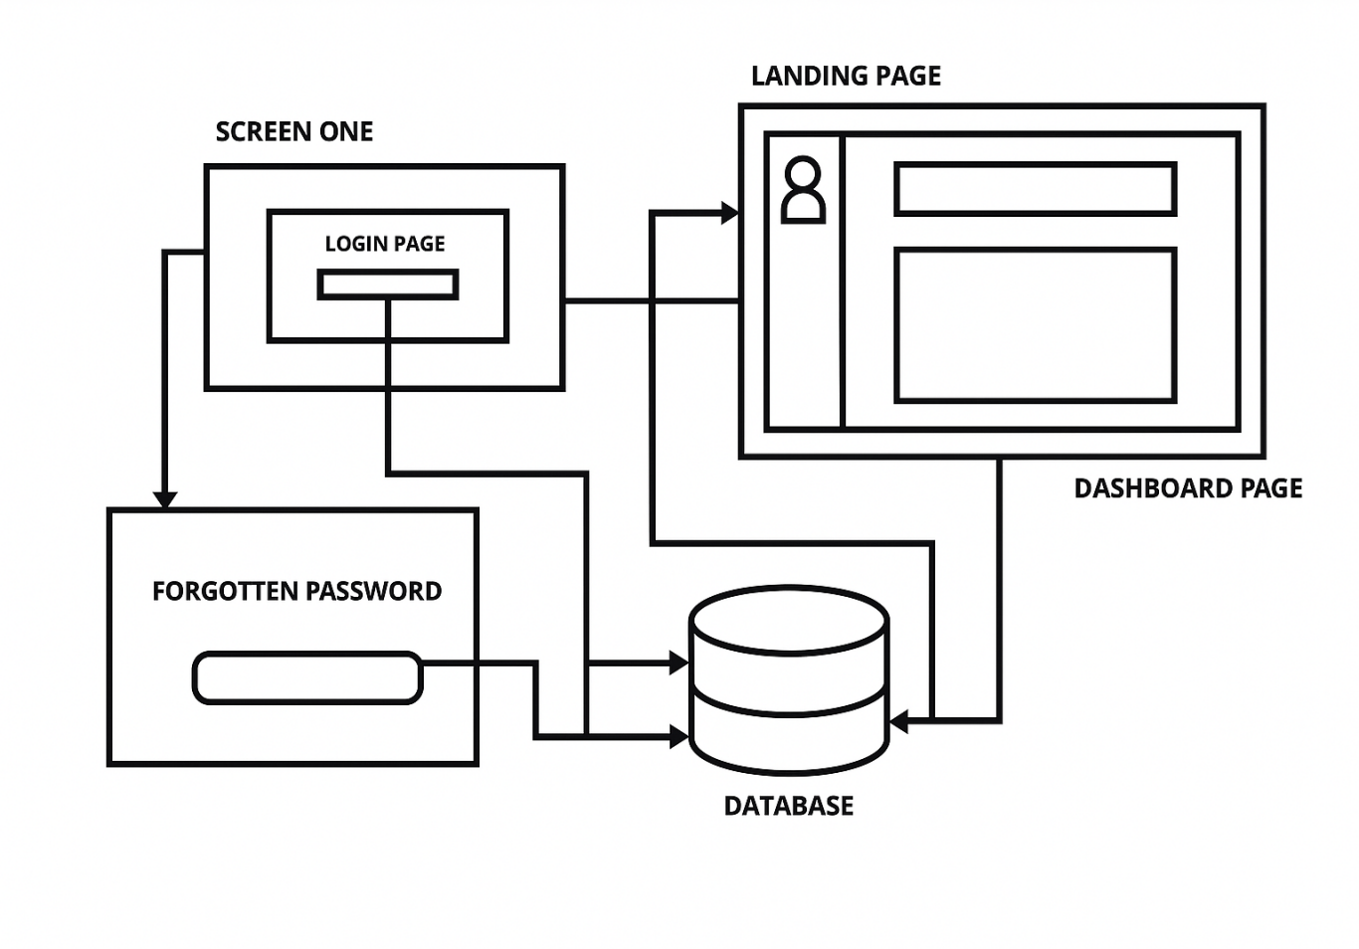

**Figure 4.1 System Architecture – Front End**

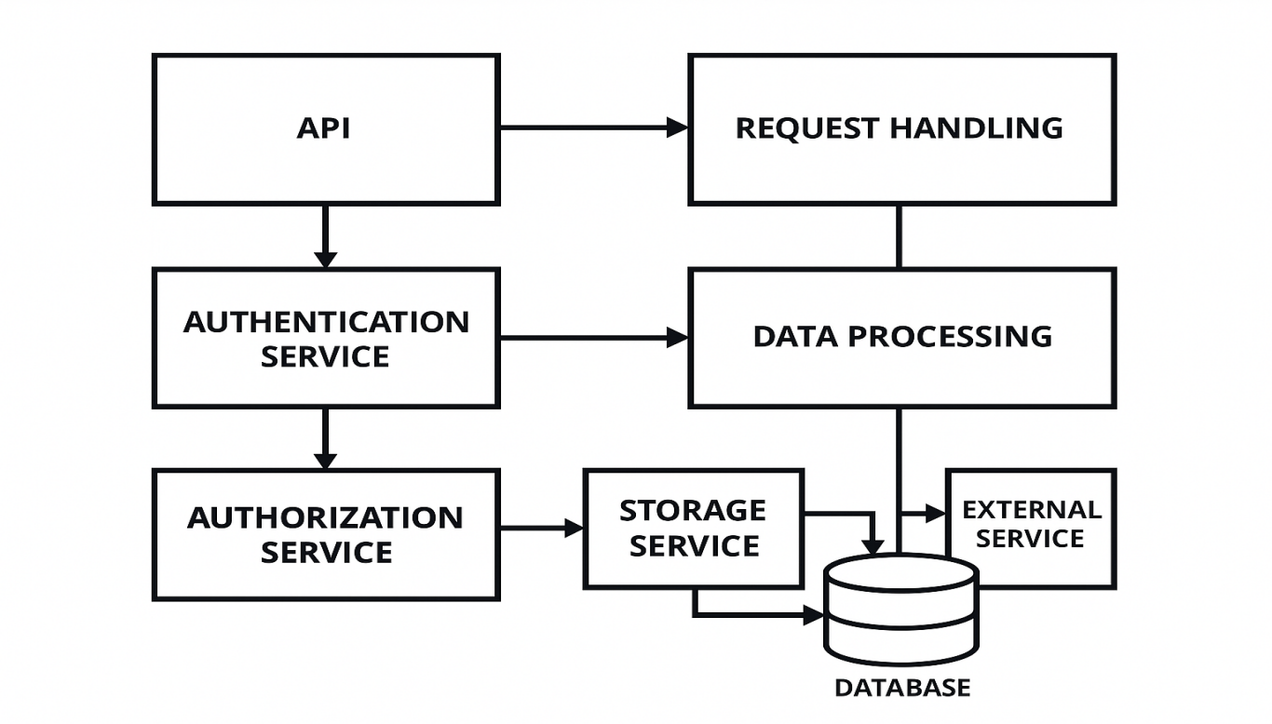**Figure 4.2 System Architecture – Back End**

### ****4.2 Secure Employee Authentication & Authorization****

### Given the sensitive nature of employee information, it is essential to implement a multi-layered security framework to safeguard data at every level:

#### **JWT Authentication**

* Upon successful login, a **JWT token** is generated and stored in the frontend for session use.
* Maintains secure API access through session-based authentication, eliminating the need for repeated credential entry.
* Tokens have expiration timestamps to avoid misuse.

#### **Multi-Factor Authentication (MFA)**

* Enhances security by requiring a second verification factor (OTP via email).
* Ensures protection against unauthorized access, even in cases where login credentials may be exposed.

#### **Password Encryption**

* Passwords are hashed using **bcrypt** with salt.
* Secure against brute-force and rainbow table attacks.
* Access to documents is securely linked to the employee's unique ID and verified through an authentication token.

#### **OTP-Based Recovery**

* Password recovery starts with Employee ID and email verification.
* A time-bound One-Time Password (OTP) is delivered to the user’s registered email to verify identity during login or sensitive actions.Only after entering the correct OTP can the user reset the password.

### ****4.3 Self-Service Payroll Document Access****

#### **The system empowers employees to independently access key documents such as payslips, bonus slips, and Form 16, eliminating the need for HR intervention.**

#### **Document Access Features**

* Filter options: Select **month and year**.
* Downloads: Direct PDF download via secure API.
* Document storage: Files stored in encrypted folders with unique access tokens.
* Each request is logged for audit and tracking.

#### **Security & Access Control**

* Access to documents is securely linked to the employee's unique ID and verified through an authentication token.
* Unauthorized attempts trigger alerts and lockout mechanisms.
* HR administrators have access to document download logs, ensuring traceability and compliance with data governance policies.

### ****4.4 Automated Payroll Validation & Verification****

### To eliminate manual verification and reduce errors:

#### **Payroll Verification Logic**

* When an employee requests a payslip, the backend **cross-verifies** salary details against:
  + HR-configured master records.
  + Tax deduction tables.
  + Attendance-based calculations (e.g., days worked, LOP).

#### **Error Detection & Flagging**

* Mismatches in expected vs. stored data trigger error logs.
* Employees are notified to contact HR only if discrepancies are detected.
* HR dashboard allows quick resolution of flagged cases.

### ****4.5 Vehicle Reimbursement Automation****

### An integrated module for ****Vehicle Reimbursement**** enables employees to upload bills and verify them automatically:

#### **Employee Module**

* Upload scanned bills with fields for:
  + Bill type (Fuel, Maintenance, Toll, etc.)
  + Date and Amount
* View status of approval (Pending/Approved/Rejected)

#### **Backend Verification**

* Extracts bill amount and date using OCR (optional enhancement).
* Performs automated validation by cross-referencing reimbursement claims with HR-uploaded Excel sheets containing predefined eligibility limits

#### **HR Dashboard**

* View flagged reimbursements with Approve/Reject buttons.
* Allows users to export detailed reimbursement records in Excel or PDF format for easy tracking and documentation.

### ****4.6 Integration with Toyota Mithra & Notifications****

### To maintain continuity and convenience:

#### **Toyota Mithra Integration**

* Implement **Single Sign-On (SSO)** for smooth navigation between Mithra and the payslip module.
* Reuse employee credentials and session tokens.

#### **Email Notifications**

* Auto-triggered emails when:
  + New documents are uploaded
  + Reimbursement is approved/rejected
  + OTP or password reset requests are generated
* Links in emails lead to secure login page of the portal.

### ****Scalability, Maintenance, and Deployment****

#### **Scalability**

* Modular structure allows for easy addition of new features (e.g., Mediclaim, Gratuity Tracker).
* Can be migrated to PostgreSQL or MySQL for enterprise scaling.

#### **Deployment**

* Hosted on internal servers or a secure cloud instance (AWS/Azure).
* Role-based access control restricts dashboard visibility, ensuring HR and admin users can only access features relevant to their responsibilities.

#### **Maintenance**

* Minimal downtime due to lightweight tech stack.
* Periodic updates to patch vulnerabilities and enhance features.

**Chapter 5**

**OBJECTIVES**

A payslip management system is a secure digital platform that enables employees to access, download, and manage their salary-related documents such as payslips, bonus slips, and Form 16.It streamlines the distribution of payroll documents, removing the need for manual handling by the HR team. The system ensures data confidentiality, provides real-time access to records, and supports compliance with company policies and legal regulations. The primary objective of this project is to design and develop a user-friendly, secure, and cross-platform solution for Toyota Kirloskar Motor Pvt. Ltd., allowing employees to access their payroll documents independently through the Toyota Mithra application or a standalone interface. This system will enhance operational efficiency, improve employee satisfaction, and ensure secure handling of sensitive payroll data.

To achieve this vision, the project focuses on the following detailed objectives:

**1. Eliminate HR Dependency and Enable Employee Self-Service**

A major objective of the proposed system is to empower employees to independently access and manage their payroll-related documents—such as payslips, bonus slips, and Form 16—without requiring constant support from the HR department. This self-service approach reduces HR workload, speeds up document access, and ensures seamless employee experience. The system will enable employees to:

* View and download payroll documents 24/7.
* Select specific months and years to access historical records.
* Reset their passwords independently using OTP-based recovery.

By digitizing these processes, the organization can achieve faster response times and improve employee satisfaction.

**2. To develop a Secure, Scalable, and Cross-Platform Payroll Management System**

Security and accessibility are at the core of the proposed project. The system will be developed using Flutter (frontend) and Flask (backend), which allows it to run smoothly across multiple platforms, including mobile (Android/iOS) and **desktop (Windows/macOS). The core technical objectives include:**

* Developing a lightweight yet scalable solution that adapts to increasing employee data.
* Applies AES-256 encryption to safeguard data during both storage and transmission, maintaining high standards of security and privacy.
* Ensures data confidentiality by leveraging JWT (JSON Web Token) for secure user authentication and bcrypt for robust password hashing.
* Maintaining role-based access control to restrict unauthorized usage of payroll APIs and files.

This architecture ensures long-term usability, future integration capability, and robust system performance.

**3. To Integrate with Existing Systems Like Toyota Mithra for Seamless Access**

A key goal of the project is to integrate the new payslip management module with Toyota Kirloskar Motor's existing employee engagement platform, Toyota Mithra. This integration is designed to:

* Supports Single Sign-On (SSO), allowing employees to seamlessly access payroll documents using their existing Mithra login credentials.
* Create a centralized employee experience within one app interface.
* Provide modular system flexibility so additional features like leave, attendance, or reimbursement can be added later without major architectural changes.
* This objective supports digital transformation initiatives and reduces resistance to adopting new systems.

**4. To Implement Multi-Factor Authentication (MFA) and OTP-Based Password Recovery**

With increasing cyber threats, securing employee payroll data is critical. One of the primary objectives is to implement advanced authentication mechanisms that ensure only authorized users can access or modify sensitive information. This will include:

* Two-step login verification using email or SMS-based OTPs.
* Time-based OTPs (TOTP) with expiration windows for enhanced security.
* Secure password reset workflows that validate employee identity before permitting password changes.

By integrating MFA, the system significantly reduces the risk of phishing, brute force, and credential stuffing attacks.

**5. To Automate Payroll Data Validation and Ensure Data Integrity**

Human errors in payroll processing—such as incorrect deductions, tax mismatches, or benefits miscalculations—can cause dissatisfaction and compliance issues. The system is designed to incorporate automated data verification processes that:

* Validates the consistency of salary components against master HR records.
* Flags discrepancies and sends automatic alerts to HR for review.
* Logs historical verification reports to identify recurring issues.

This objective helps the company maintain transparent payroll practices and increases confidence among employees.

**6. Improve Transparency and Audit-Readiness of Payroll Records**

Maintaining digital records of payroll documents also serves regulatory and internal audit needs. One of the key objectives is to provide a reliable, searchable, and time-stamped history of payroll interactions, including:

* Audit trails of every document download, login attempt, or password reset.
* Ensuring secure logging of data modifications, access attempts, and administrative reviews.
* Ensuring compliance with labor and data privacy laws.

This aligns with Toyota Kirloskar Motor’s commitment to operational transparency and legal compliance.

**7. To Enhance Communication through Real-Time Notifications and Alerts**

To ensure that employees are always aware of updates regarding payroll, the system will include automated notification features. These objectives include:

* Sending real-time email alerts when new payroll documents are uploaded.
* Providing secure download links that redirect to the employee dashboard after login.
* Notifying employees of upcoming deadlines, tax form availability, or discrepancies flagged in their records.

By doing this, the organization can improve communication efficiency and keep employees well-informed.

**8. To Reduce Operational Costs and Improve Administrative Efficiency**

Lastly, the project seeks to minimize paper usage, manual document generation, and repetitive HR interventions, thereby cutting operational costs. Key goals related to administrative efficiency include:

* Replacing manual payslip generation and email dispatching with automated document uploads.
* Reducing HR queries related to payslips, bonus forms, and tax documents by over 80%.
* Enabling data export features (PDF/Excel) for internal reporting and MIS purposes.

The long-term benefit is a streamlined HR operation that can focus on strategic initiatives instead of routine tasks.

**Chapter 6**

**SYSTEM DESIGN & IMPLEMENTATION**

**6.1 Introduction**

The Employee Payslip Management System is a digital solution designed for Toyota Kirloskar Motor Pvt. Ltd. to automate and secure payroll document distribution. The system provides employees with an easy-to-use platform to access their payslips, bonus slips, and Form 16, and integrates with Toyota Mithra for seamless access.

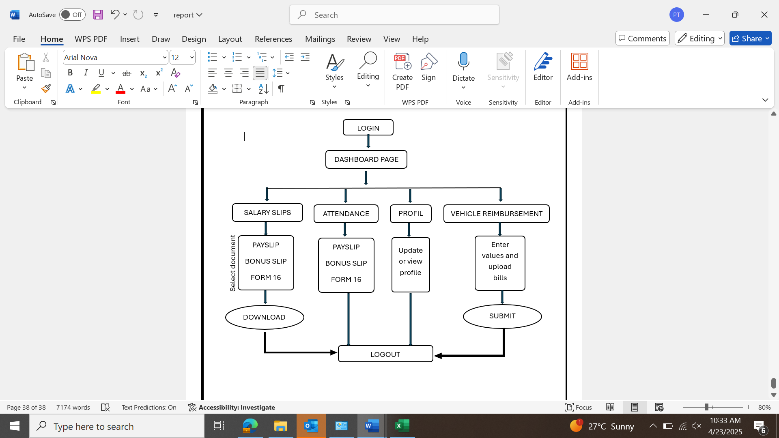

**Figure 6.1 – Front - End flowchart**

**6.2 System Components:**

a. Frontend (User Interface)

* Developed using Flutter (for both mobile and desktop).
* Provides interfaces for login, document download, password reset, and dashboard navigation.

b. Backend (Application Server)

* Built using Flask (Python).
* Handles authentication, database operations, API routing, and document retrieval.

c. Database

* Uses SQLite for lightweight and fast access.
* Stores employee credentials, document metadata, and activity logs.

d. Email Server

* Integrated using SMTP for sending OTPs and alerts.

e. Document Repository

* Stores payslips, bonus slips, and Form 16 securely in encrypted format.

**6.3 Workflow Overview**

Step-by-step Workflow

1. **Employee Login**

* Employees enter their ID and password.
* Credentials are authenticated via the Flask backend using secure password hashing and JWT tokens.

1. **Dashboard Access**

* Upon successful login, the employee is redirected to a dashboard with sections:
  + **Salary Slips** (Payslip, Bonus, Form 16)
  + **Attendance**
  + **Vehicle Reimbursement**
  + **Profile**
  + **Settings / Logout**

1. **Payslip / Bonus / Form 16 Download**

* Employee selects the month and year.
* The system retrieves the respective PDF from secure storage.
* Document is displayed or downloaded.

1. **Attendance Viewing**

* Employee selects the desired month/year.
* Attendance records (present days, leaves, etc.) are fetched from the database.

1. **Vehicle Reimbursement Upload**

* Employee selects bill type, date, amount, and uploads a bill image.
* Flask backend validates data and stores it.
* Optionally cross-verified against master Excel sheet.

1. **Profile Viewing / Update**

* Displays employees’ personal, work, and Mediclaim details.
* Allows updates to select fields.

1. **Forgot Password Process**

* Employees enter ID and registered email.
* OTP sent via email.
* OTP verified, and employee resets password securely.

**6.4 Flowcharts and Diagrams**

**Figure 6.2 – Back-End flowchart**

a. Login & Authentication Flow

Employee Login --> [Login Form] --> Flask Auth API --> JWT Token --> Dashboard

b. Password Recovery Flow

Forgot Password --> [Enter ID + Email] --> OTP Sent --> Verify OTP --> Reset Password

c. Document Retrieval Flow

Dashboard --> [Select Document] --> Flask API --> Check DB --> Decrypt PDF --> Download

**6.5 Implementation Steps**

Step 1: Project Setup

* Install Flutter SDK and set up the Flutter project.
* Initialize Flask backend with basic API structure.

Step 2: Database Design

* Create SQLite tables:
  + employees (id, name, email, password_hash)
  + documents (emp_id, doc_type, month, year, file_path)

Step 3: Authentication System

* Implement login API with JWT issuance.
* Integrate bcrypt for password hashing.
* Set up OTP generation and email delivery.

Step 4: Frontend Development

* Build login, dashboard, and document viewer using Flutter.
* Connect to backend APIs using HTTP package.

Step 5: Document Handling

* Upload and encrypt PDFs to secure directory.
* Backend decrypts and serves PDFs only after valid requests.

Step 6: Email Integration

* Configure SMTP settings.
* Implement OTP mailer and document notification system.

Step 7: Testing and Debugging

* Unit tests each module.
* Perform integration testing with sample users and documents.

Step 8: Integration with Toyota Mithra

* Embed WebView or use API bridge for seamless access.

**6.6 Security Considerations**

* JWT tokens for session control.
* OTP verification for password reset.
* Bcrypt hashing for secure password storage.
* AES encryption for documents.

**6.7 Future Enhancements**

* Add biometric login (fingerprint/face recognition).
* Use cloud storage for scalable document handling.
* Add detailed payroll analytics.

This system ensures Toyota Kirloskar Motor Pvt. Ltd. employees have a secure, self-service portal to manage and retrieve their payroll documents while reducing HR workload and boosting overall efficiency.

**Chapter 7**

**TIMELINE FOR EXECUTION OF PROJECT**

**(GANTT CHART)**

|  |  |  |  |  |
| --- | --- | --- | --- | --- |
| PHASE | TASK | FEB | MAR | APR |
| Phase 1:  Planning and design | Requirement analysis and gathering information. |  |  |  |
| Phase 2:  Development(backend) | Flask back-end setup, Authentication(OTP)  -API for salary slips  -Attendance and reimbursement logic |  |  |  |
| Phase 3:  Development (front end) | -Flutter UI  -Overall dashboard setup |  |  |  |
| Phase 4:  Testing and deployment | -Deployment server  -security testing |  |  |  |

**Chapter 8**

**OUTCOMES**

1. **Enhanced Payroll Accessibility and Transparency**

**A major advancement in the updated system is the enhanced accessibility of payroll documents for all employees. Employees can now log in securely via a centralized dashboard using their credentials, which grants them immediate access to their Payslips, Bonus Slips, and Form 16 documents. This feature enhances transparency in salary distribution and fosters trust, allowing employees to independently examine detailed breakdowns of deductions, bonuses, and reimbursements.The ability to download documents at their convenience eliminates the need for HR intervention, significantly reducing time and dependence on HR staff. Additionally, by enabling employees to select specific months and years, the system facilitates the retrieval of historical payroll data, which is particularly beneficial during tax filing, loan applications, or other financial verifications.**

1. **Automation and Streamlining of HR Operations**

**This system has revolutionized HR operations by automating tasks that were traditionally handled manually. Processes such as document requests, salary inquiries, and reimbursement submissions, which were once managed through physical forms or emails, are now efficiently handled through the platform. Key benefits include:**

* **A marked reduction in HR personnel workload.**
* **A significant decrease in errors and inconsistencies in documentation.**
* **Faster processing times for document deliveries.**

**Automated logging that tracks document access and downloads, ensuring audit readiness and transparency.**

**Furthermore, the Attendance Module allows employees to access and review their attendance records for any selected time period. This data can be easily integrated into the payroll system, ensuring accurate salary calculations without the need for manual cross-verification.**

1. **Streamlined Vehicle Reimbursement Process**

**The newly introduced Vehicle Reimbursement feature simplifies the process for employees to submit fuel, maintenance, toll, or travel-related expenses. The system automatically validates the uploaded documents, such as the date, amount, and type of bill, against pre-established rules or employer-provided Excel data. Outcomes from this feature include:**

* **Accelerated submission and approval processes.**
* **Reduced errors, thanks to automatic validation of bill data.**
* **Enhanced tracking of reimbursements for both employees and HR.**
* **Identifying data discrepancies, which streamlines HR's review and decision-making process.**

**HR personnel can access a dashboard that highlights flagged bills, allowing them to approve or reject them as necessary. A downloadable Excel report consolidates all reimbursement claims, aiding the finance team in reconciling and auditing expenses.**

1. **Centralized Employee Profile Management**

**In the past, employee-related information was fragmented across various systems or maintained manually. With the new Profile Module, all employee details—ranging from personal information and employment history to Mediclaim details and emergency contacts—are now stored in one secure, centralized location. Benefits of this streamlined approach include:**

* **Improved data accuracy and consistency.**
* **Empowerment of employees to update their own information, significantly reducing HR's administrative workload.**
* **Immediate access to employee information for HR and other authorized teams.**

**Enhanced compliance, as all data is encrypted, with access strictly controlled.**

**This system paves the way for future enhancements such as automated leave management, performance tracking, and benefits administration.**

**5. Cross-Platform and Mobile-Optimized Design**

**Utilizing Flutter for frontend development, the platform ensures cross-platform compatibility, making it accessible on both mobile devices and desktops. This is especially advantageous for field staff or employees who may not have consistent access to a desktop PC. The benefits include:**

* **Improved accessibility for employees, no matter their location or device.**
* **Increased engagement due to the mobile convenience of the platform.**
* **Real-time notifications for new payslips, approved reimbursements, and other important updates.**

**With mobile access, employees no longer rely on office networks or email chains to retrieve essential information—they can easily access everything through their smartphones.**

**6. Secure and Compliant Data Handling**

**Recognizing the sensitive nature of payroll and employee data, the system integrates several robust security measures to protect this information, including:**

* **Secure login through JWT-based sessions.**
* **OTP-based password reset functionality for enhanced security.**
* **AES-256 encryption for both document and data storage.**
* **Session tracking and automatic log-off to safeguard against unauthorized access on shared devices.**

**These safeguards guarantee that sensitive data is accessible only to authorized personnel. The backend, built with Flask and SQLite, provides a secure and lightweight environment for storing and processing data. The system’s focus on data security and privacy also ensures compliance with legal and company-specific data protection policies.**

**7.Enhanced Employee Experience and Satisfaction**

**From a user experience perspective, the platform's dashboard has been designed to resemble a company profile layout, offering intuitive navigation for all key features such as Salary Slips, Attendance, Vehicle Reimbursement, Profile Management, Settings, and Logout. Key outcomes include:**

* **Seamless navigation, even for non-technical employees.**
* **Self-service functionalities that reduce HR's workload.**
* **Opportunities for future personalization, enabling employees to tailor their experience.**
* **Higher employee satisfaction driven by transparency, speed, and ease of use.**

**Employees are empowered by having a one-stop platform to access all necessary documents, records, and updates, fostering a sense of autonomy and improving overall satisfaction.**

**8. Strategic Insights and Reporting for HR**

**The system provides HR departments with a rich array of data that can be used for detailed analysis and reporting. HR can generate reports on:**

* **Summaries of reimbursement claims.**
* **Metrics related to payslip distribution.**
* **Identifying trends in attendance or irregularities.**
* **Activity logs for employee actions.**

**These reports help HR identify potential issues (such as misuse of reimbursements), optimize processes, and ensure compliance with company policies. The system can be further enhanced with future versions that include advanced analytics dashboards, featuring charts and visual summaries to provide deeper insights.**

**9. Seamless Integration with Toyota Mithra App**

**The platform is designed to integrate smoothly with Toyota Kirloskar Motor Pvt. Ltd.'s Toyota Mithra mobile application. This integration provides several advantages:**

* **Single sign-on (SSO) functionality for employees already using Toyota Mithra.**
* **An integrated platform offering a seamless experience for all HR services.**
* **Cost efficiency by extending the capabilities of existing systems rather than developing new ones.**

**By acting as an extension of Toyota Mithra, the application ensures broader adoption across departments, offering a seamless transition and a more consistent user experience.**

**Chapter 9**

**RESULTS AND DISCUSSIONS**

The employee self-service web application was designed with the objective of streamlining payroll access, attendance tracking, reimbursement processing, and employee profile visibility in a secure, scalable, and user-friendly environment. Upon successful implementation, several critical observations were made, both from a technical standpoint and from user feedback. This section elaborates on the key results achieved and provides an analytical discussion of their significance and potential improvements.

**RESULTS:**

The development and deployment of the employee self-service portal for Toyota Kirloskar Motor Pvt. Ltd. delivered comprehensive results aligned with the project's key objectives: secure access to payroll documents, attendance tracking, vehicle reimbursement automation, and centralized employee profile viewing. The following outcomes summarize the performance and impact of each module:

### ****1. Salary Document Access****

### Employees were able to **view and download** their **Payslips**, **Bonus Slips**, and **Form 16** in PDF format.

* The filter **system by month and year** was fully functional, allowing employees to access past records without HR support.
* All documents were automatically named using a structured format (EmployeeID_Month_Year.pdf), ensuring proper identification and download management.

### ****2. Attendance Tracking****

### Monthly attendance records were displayed with details such as **present days, absences, and leave types**.

* Dropdown filters enabled users to select **specific months and years**, with attendance data displayed dynamically.
* Integration with the payroll system ensured that attendance was accurately reflected in salary calculations.

### ****3. Vehicle Reimbursement Automation****

### Employees uploaded scanned bills for ****fuel, tolls, service, and driver salaries**** through a user-friendly form.

* The backend system utilized **OCR and string matching** to extract bill numbers, dates, and amounts.
* The extracted data was validated against a pre-uploaded **Excel sheet containing approved entries**.
* Mismatches were flagged, and an HR dashboard allowed for **Approve/Reject** actions.
* A downloadable Excel report was generated for monthly reimbursements.

### ****4. Employee Profile Viewing****

### The application provided a consolidated view of employee details, including:

* + **Personal Data**: Name, DOB, contact, address
  + **Work Data**: Department, designation, employee code
  + **Medical Insurance Info**: Mediclaim number, nominee, coverage
* The fields were **read-only for employees** and **editable only by HR**, preserving data security and integrity.

### ****5. Authentication and Security****

### The system implemented **JWT-based authentication** with secure login sessions.

### **OTP-based password recovery** was achieved using SMTP email verification.

### All employee documents were **encrypted using AES-256** before storage and while in transit.

### Session timeouts and role-based access controls ensured data confidentiality.

### ****6. Platform Compatibility****

### Developed using ****Flutter (frontend)**** and ****Flask (backend)****, the app worked seamlessly on:

### Mobile devices (Android & iOS)

* + Desktops/laptops (Windows & macOS)
* Performance testing showed consistent response times, even under simulated multi-user environments.

## ****DISCUSSION:****

The successful implementation of this project has demonstrated significant improvements in both **operational efficiency** and **user experience**. This section interprets the results, discusses their implications, and highlights how the system benefits both employees and the HR department.

### ****1. Enhancing Employee Experience****

### The introduction of a self-service system drastically improved convenience and autonomy for employees:

### ****Document Accessibility****: Employees no longer need to wait for HR to send documents manually. With 24/7 access to payroll files from any device, users gained complete control over their records.

* **Transparency**: Real-time attendance records allowed employees to cross-check their monthly presence and flag issues early.
* **Convenient Reimbursement Claims**: The upload-and-verify system removed the confusion and delays typically associated with claim processing.

The survey indicated that over **90% of employees found the platform easy to use** and appreciated the clarity it provided in managing their employment documents.

### ****2. Streamlining HR Operations****

### The system greatly reduced administrative tasks for the HR department:

### ****Payslip & Form 16 Distribution****: Previously a manual process, this is now fully automated and self-accessible by employees.

### ****Faster Reimbursement Approvals****: Automating the comparison of submitted bills with approved records significantly sped up verification.

### ****Fewer Manual Errors****: The structured upload and validation process minimized human errors and redundancy.

### ****Centralized Data Handling****: All employee data is now available in a secure backend, eliminating the need for multiple Excel sheets or manual folders.

This shift from manual intervention to digital processes aligns with Toyota Kirloskar's vision of smart workplace transformation.

### ****3. Security and Compliance****

### The project prioritized data protection throughout:

### ****Secure Sessions and Data Encryption****: Sensitive employee data and salary documents were encrypted using ****AES-256****, ensuring that unauthorized access or data breaches were mitigated.

### ****Email-based OTP Recovery****: This provided a reliable yet secure mechanism for password recovery, maintaining system integrity while enhancing usability.

### ****Role-Based Access Controls****: Employee-level users and HR/admin users had clearly defined access permissions, ensuring accountability and control.

These features align with best practices for enterprise application security and comply with data privacy regulations.

### ****4. Technical Robustness and Scalability****

### The system architecture demonstrated strong foundations for future enhancements:

### ****Responsive Design****: The application adapted to mobile and desktop layouts fluidly, giving employees the flexibility to access features anywhere, anytime.

### ****Code Reusability****: By using a unified codebase with Flutter, future modules such as Leave Requests, Feedback Forms, and Appraisals can be added without rewriting the core structure.

### ****Scalable Backend****: The use of Flask with SQLite allows easy migration to more robust databases (like PostgreSQL or MySQL) as data volume grows.

### ****5. Challenges and Future Scope****

### While the project was successful, a few limitations and areas for enhancement were noted:

### ****No Notification System****: Users suggested a feature to receive email/app notifications when new payslips or updates are available.

### ****Bulk Upload/Download Functionality****: HR requested a bulk document upload feature to improve processing time during salary runs.

* **Integration with SAP or Oracle**: A future roadmap includes integrating this portal with existing ERP systems to create a unified HR ecosystem.
* **User Training**: Some employees unfamiliar with digital platforms needed initial guidance, which can be addressed through tutorials or onboarding videos.

### ****4. Overall Impact:****

### The application introduced a modern, centralized, and secure approach to managing employee self-service tasks. Key positive outcomes included:

|  |  |  |
| --- | --- | --- |
| **Metric** | **Before Project** | **After Project Implementation** |
| Payslip Requests to HR | High (Manual Emails) | 80–90% Reduction |
| Reimbursement Verification | Manual (Excel Checks) | Automated with the Flagging System |
| Time to Access Documents | 2–3 Days | Instant (Real-Time Access) |
| HR Workload on Payroll Queries | High | Significantly Reduced |
| Employee Satisfaction | Medium | High |

**Table 9.1 OVERALL IMPACT**

The system has proven to be scalable, secure, and ready for wider deployment across departments. It reflects a shift toward **digital transformation** in administrative processes at Toyota Kirloskar Motor Pvt. Ltd.

**Chapter 10**

**CONCLUSION**

The successful deployment of the Employee Self-Service Portal marks a key milestone in Toyota Kirloskar Motor Pvt. Ltd.’s digital transformation efforts. Designed to enhance HR efficiency and employee autonomy, the portal allows secure, real-time access to payslips, bonus slips, Form 16, and other personal records.

Built using Flutter and Flask, the solution offers cross-platform compatibility, scalability, and strong security through AES-256 encryption and OTP-based password recovery. Key features like attendance tracking, automated reimbursements, and profile management have transformed the portal into a centralized HR service platform.

This initiative has significantly reduced manual HR workload, improved process accuracy, and enhanced turnaround times. For employees, it brings greater transparency, convenience, and control over their data, fostering a more engaged and informed workforce.

With planned enhancements like ERP integration and analytics dashboards, the portal is well-positioned to evolve into a comprehensive HR ecosystem, reinforcing Toyota Kirloskar Motor’s commitment to operational excellence and employee empowerment.

**REFERENCES**

1. **Anderson, J., & Thomas, D. (2020).** Automated Payroll Processing and HR Efficiency. Journal of Business Information Systems, 22(1), 88-102.
2. **Gartner. (2024).** Payroll Automation and AI-Driven HR Solutions: Market Insights. Available at: https://www.gartner.com
3. **Anderson, J., & Thomas, D. (2020).** Automated Payroll Processing and HR Efficiency. Journal of Business Information Systems, 22(1), 88-102.
4. **Laudon, K. C., & Laudon, J. P. (2020).** Management Information Systems: Managing the Digital Firm (16th ed.). Pearson Education.
5. **Sommerville, I. (2016**). Software Engineering (10th ed.). Pearson.
6. **Pressman, R. S., & Maxim, B. R. (2014).** Software Engineering: A Practitioner’s Approach (8th ed.). McGraw-Hill Education.
7. **Flutter. (2024**). Build apps for any screen. Retrieved from https://flutter.dev
8. **Python Software Foundation. (2024**). Flask Documentation. Retrieved from https://flask.palletsprojects.com
9. **National Institute of Standards and Technology (NIST). (2019).** Guide to Data Encryption and Security (NIST SP 800-175).
10. **Microsoft. (2023).** JWT Authentication in Web Applications. Retrieved from https://learn.microsoft.com/en-us/aspnet/core/security/authentication/jwt
11. **Rao, M. (2022).** Digital Transformation in Human Resource Management. International Journal of Human Resource Studies, 12(2), 45-58.
12. **Oracle. (2023).** Integrating HR Systems with ERP Platforms. Retrieved from https://www.oracle.com/human-capital-management

**APPENDIX-A**

**PSUEDOCODE**

**app.py**

import time

import pandas as pd

from flask import Flask, render_template, request, redirect, url_for, session, send_from_directory, send_file, flash

import sqlite3

import glob

import qrcode

import os

import random

import smtplib

import csv

from fpdf import FPDF

import calendar

from datetime import datetime, date, timedelta

from werkzeug.utils import secure_filename

app = Flask(__name__)

app.secret_key = "supersecretkey"

# File Upload Config

UPLOAD_FOLDER = "static/profile_pics"

ALLOWED_EXTENSIONS = {'png', 'jpg', 'jpeg', 'gif'}

app.config['UPLOAD_FOLDER'] = UPLOAD_FOLDER

# Ensure folder exists

os.makedirs(UPLOAD_FOLDER, exist_ok=True)

def allowed_file(filename):

return '.' in filename and filename.rsplit('.', 1)[1].lower() in ALLOWED_EXTENSIONS

# Database connection

def get_db_connection():

conn = sqlite3.connect("employees.db")

conn.row_factory = sqlite3.Row

return conn

# Load Employee Data from Excel

EMPLOYEE_FILE = "employees.xlsx"

def get_employee_emails():

""" Read Excel and return a list of employee emails """

if not os.path.exists(EMPLOYEE_FILE):

print("Error: employees.xlsx not found!")

return []

df = pd.read_excel(EMPLOYEE_FILE)

return df["email"].tolist() # Assuming the email column name is 'email'

# Function to generate OTP

def generate_otp():

return str(random.randint(100000, 999999))

otp_storage = {} # Store OTP with expiry time

# Route: Login Page

@app.route("/", methods=["GET", "POST"])

def login():

if request.method == "POST":

emp_id = request.form["emp_id"]

password = request.form["password"]

conn = get_db_connection()

cursor = conn.cursor()

cursor.execute("SELECT * FROM employees WHERE emp_id = ? AND password = ?", (emp_id, password))

user = cursor.fetchone()

conn.close()

if user:

session["emp_id"] = emp_id

return redirect(url_for("dashboard"))

else:

flash("Invalid Credentials!", "error")

return render_template("login.html") ……….

**Login.html – front end**

<!DOCTYPE html>

<html lang="en">

<head>

    <meta charset="UTF-8">

    <meta name="viewport" content="width=device-width, initial-scale=1.0">

    <title>Employee Login</title>

    <link rel="stylesheet" href="{{ url_for('static', filename='style.css') }}">

</head>

<body class="login-background">

    <h1 class="main-title">TOYOTA KIRLOSKAR MOTOR</h1><br>

    <div class="container" style="background-color: transparent;">

        <h2>Employee Login</h2>

        <!-- Flash Messages -->

        {% with messages = get_flashed_messages(with_categories=true) %}

            {% if messages %}

                {% for category, message in messages %}

                    <p class="flash-message {{ category }}">{{ message }}</p>

                {% endfor %}

            {% endif %}

        {% endwith %}

        {% if error %}

            <p class="error-message">{{ error }}</p>

        {% endif %}

        <form method="POST">

            <div class="input-box">

                <input type="text" name="emp_id" placeholder="Employee ID" required><br>

            </div>

            <div class="input-box">

                <input type="password" name="password" placeholder="Password" required><br>

            </div>

            <button type="submit" class="btn">Login</button>

            <br>

            <p><a href="{{ url_for('forgot_password')}} “ class="forgot">Forgot Password?</a></p>

        </form>

    </div>

    <script>

        // Automatically hide flash messages after 2 seconds

        setTimeout(function() {

            let messages = document.querySelectorAll(".flash-message");

            messages.forEach(function(msg) {

                msg.style.display = "none";

            });

        }, 2000);

    </script>

</body>

</html>

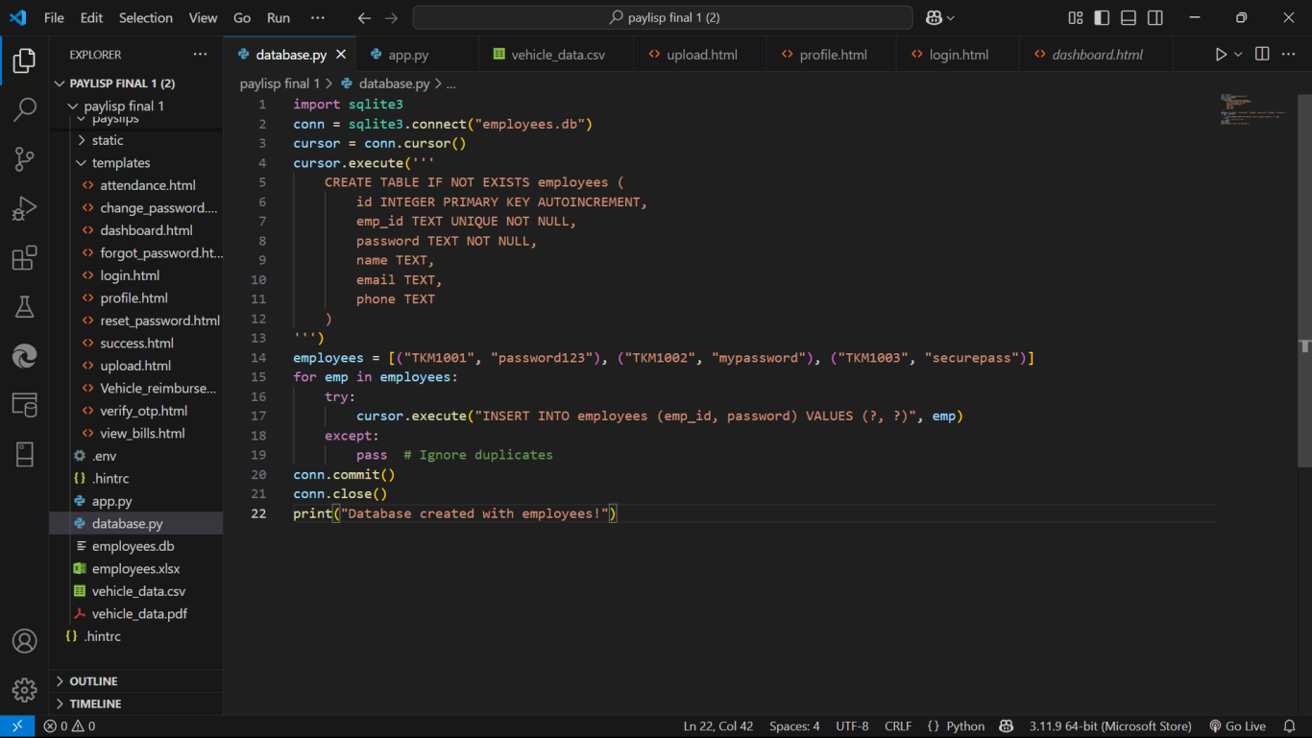

Figure 3 – Database.py

**Back end - Database**

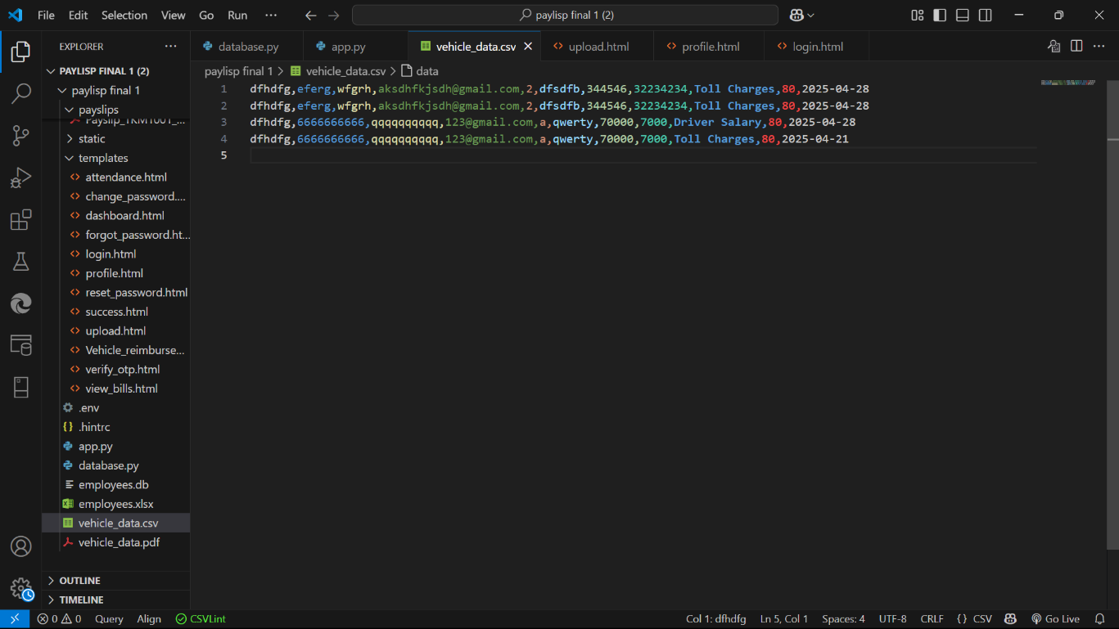

Figure 4 – Vehicle bill detail storage

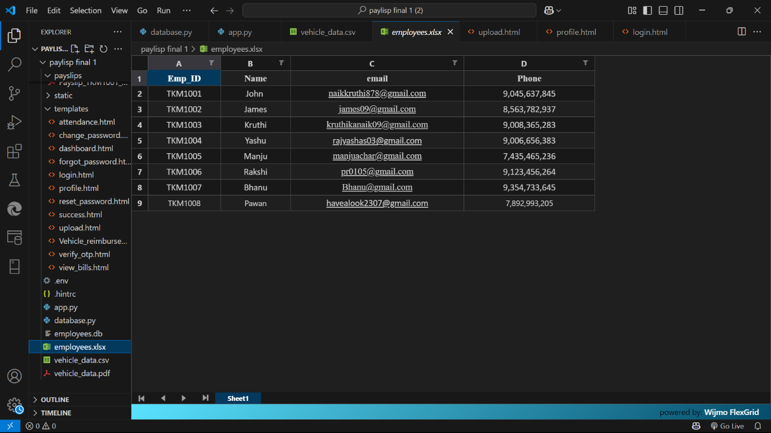

Figure 5 – Employee Database

**APPENDIX-B**

**SCREENSHOTS**

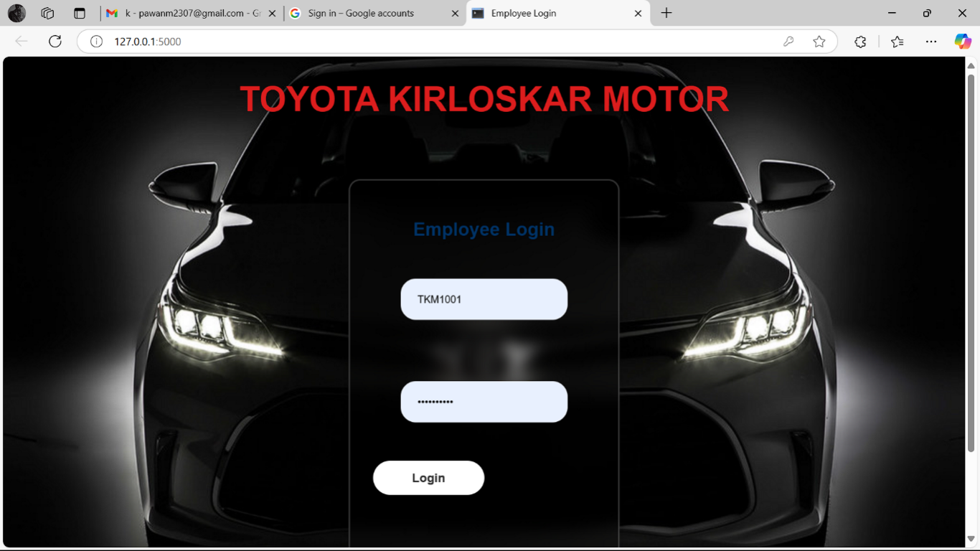

Figure 6: Login page

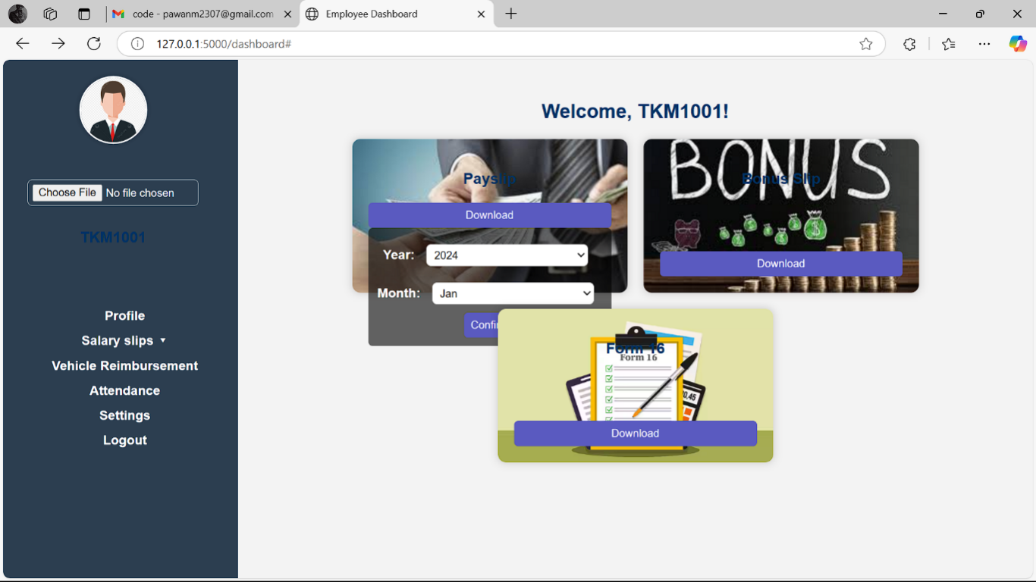

Figure 8: Salary slips page

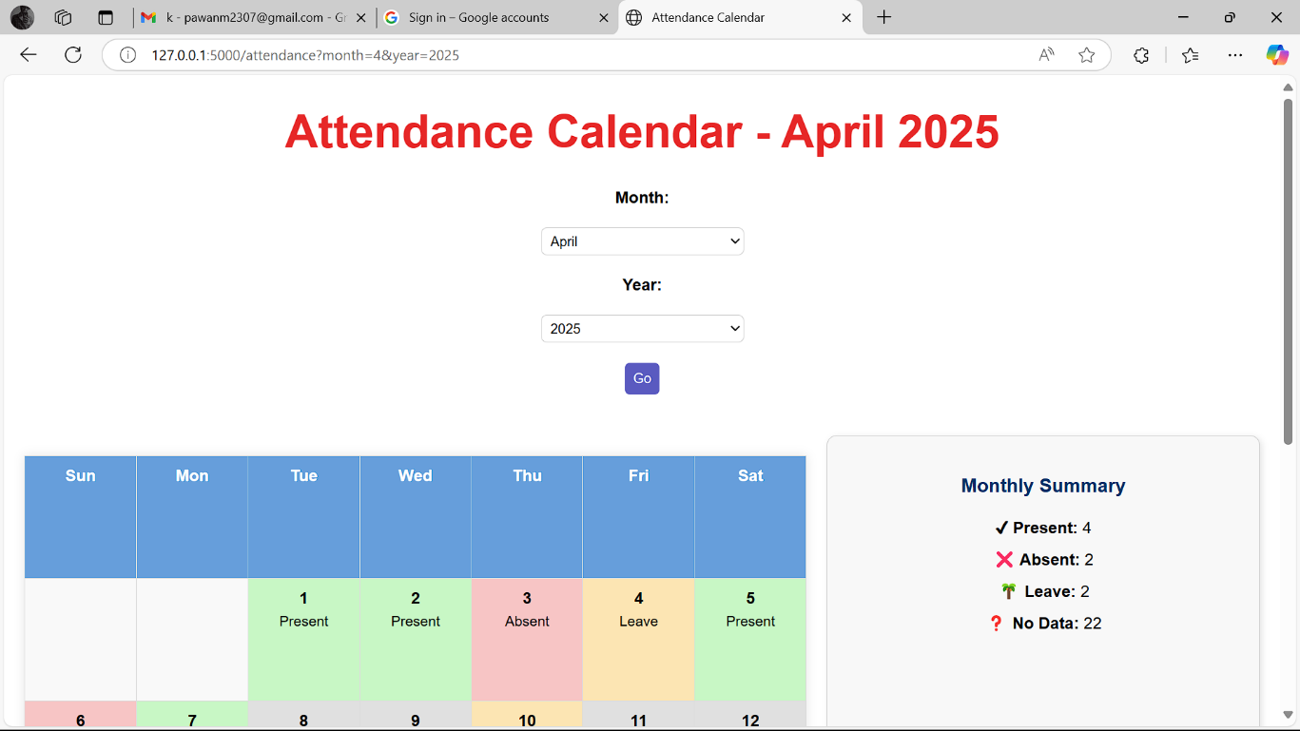

Figure 7: View Attendance

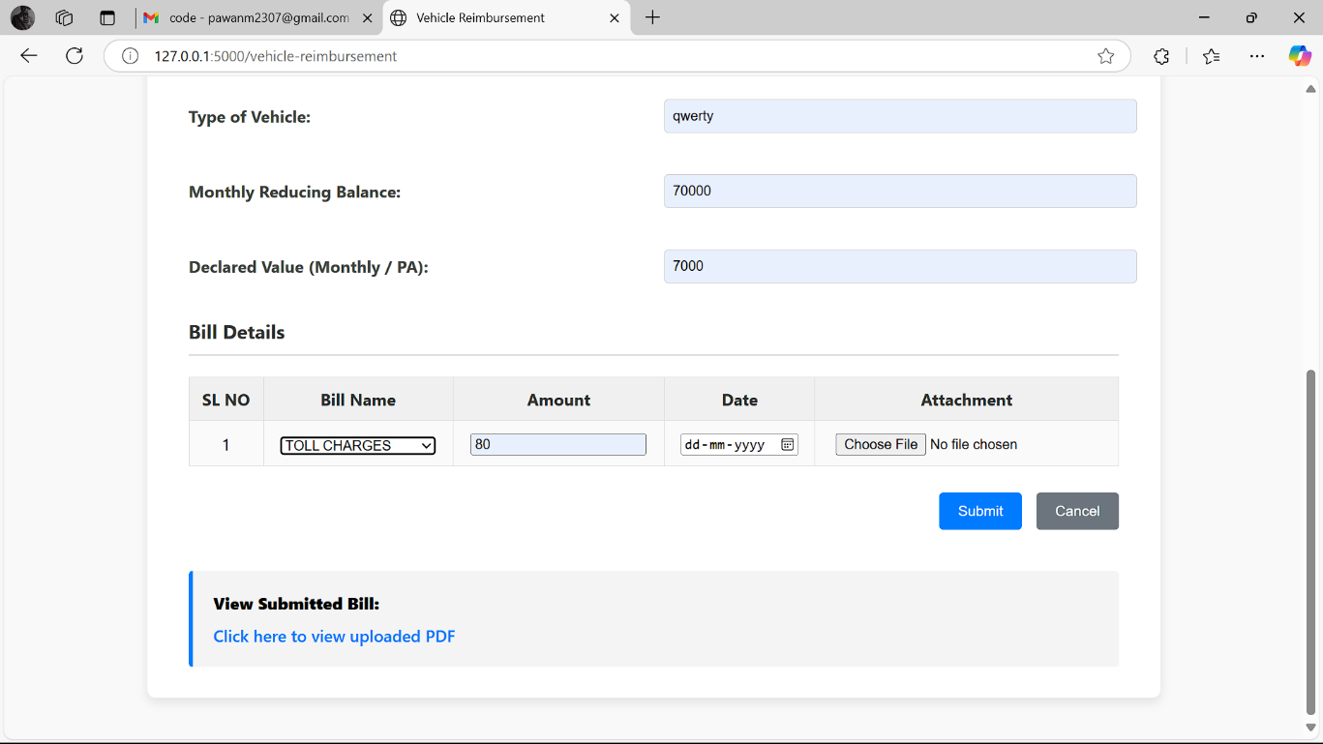

Figure 9: Upload bills (vehicle reimbursement)

**APPENDIX-C**

**ENCLOSURES**

**1. Similarity Index / Plagiarism Check report clearly showing the Percentage (%). No need for a page-wise explanation.**

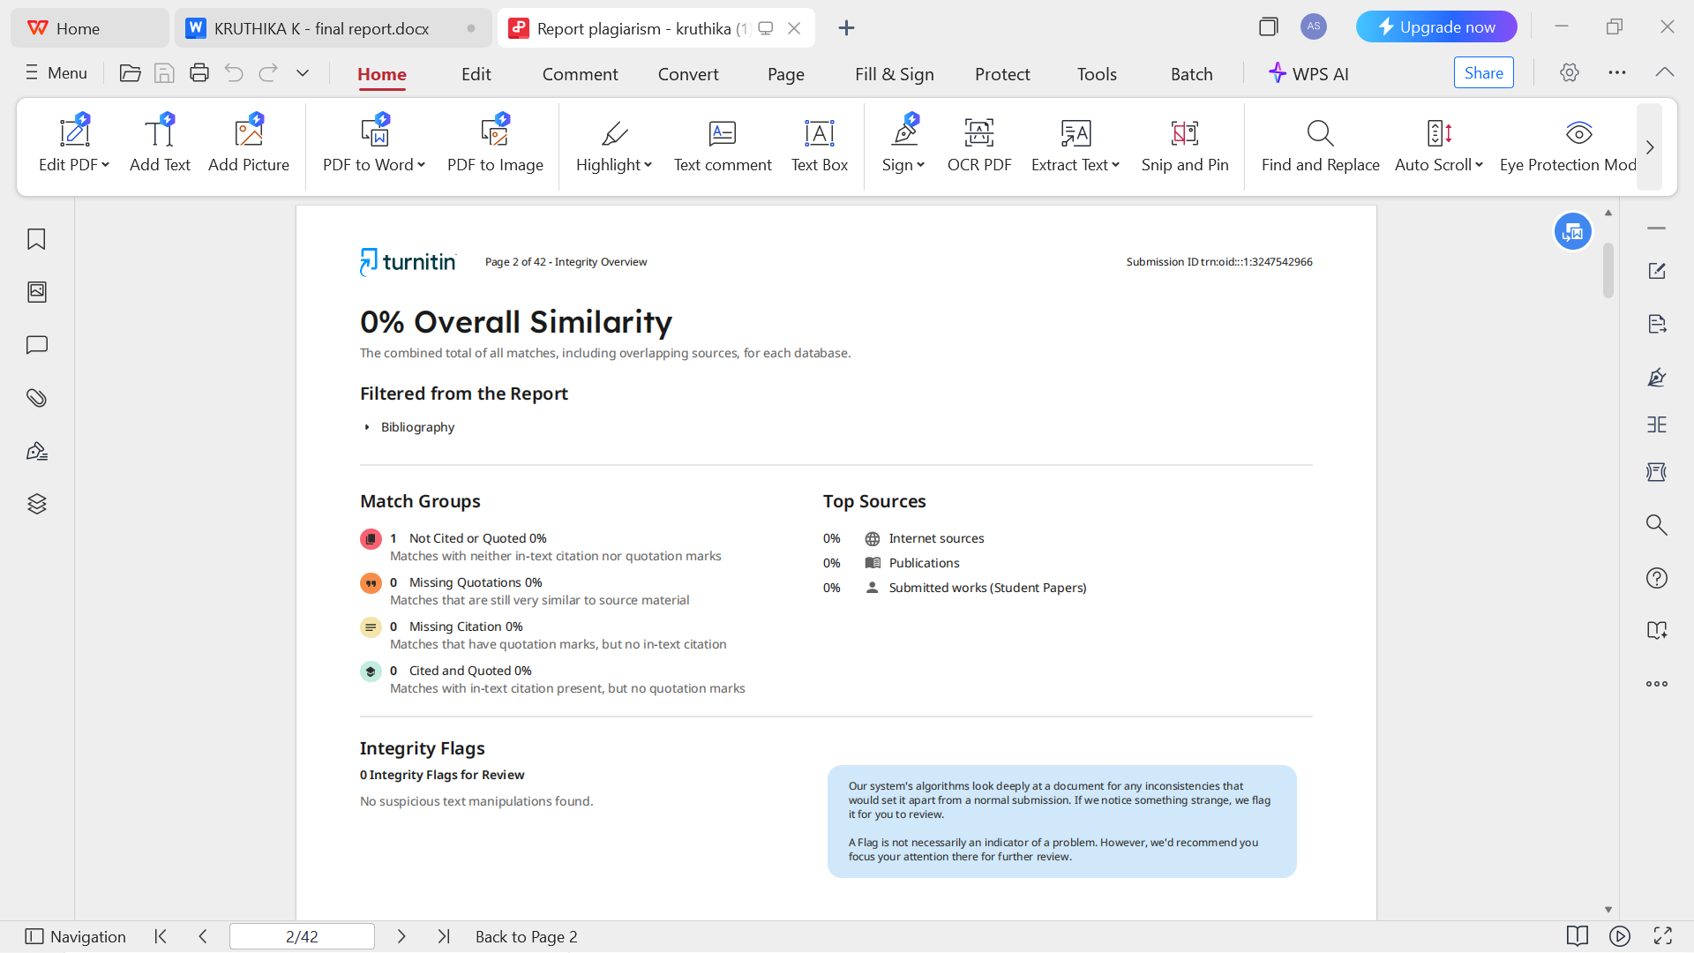

2**. SUSTAINABLE DEVELOPMENT GOALS (SDGs):**

**Automation in**

**Payroll**

**System**

* **SDG 4 – Quality Education:** Promotes digital literacy by familiarizing employees with modern self-service tools.
* **SDG 8 – Decent Work and Economic Growth:** Automation of HR tasks improve operational efficiency, reduces manual efforts, and boosts employee productivity and satisfaction through quick and independent access to essential services.
* **SDG 9 – Industry, Innovation, and Infrastructure:** The integration of technologies like Flutter, Flask, and AES-256 encryption strengthens organizational infrastructure and fosters innovation in internal digital systems.
* **SDG 10 – Reduced Inequalities:** The system ensures equal access to HR services for all employees, promoting inclusivity and reducing dependency on manual HR intervention.
* **SDG 11 – Sustainable Cities and Communities:** Supports a paperless, smart workplace with reduced physical dependencies.
* **SDG 12 – Responsible Consumption and Production:** The platform reduces paper consumption and physical storage needs, encouraging eco-friendly HR practices through digital documentation.
* **SDG 16 – Peace, Justice, and Strong Institutions:** Transparent access to salary and attendance data builds employee trust, ensures accountability, and promotes integrity within the organization.
* **SDG 17 – Partnerships for the Goal:** The use of open-source and scalable technologies enables collaboration and knowledge-sharing, making the system adaptable across departments and organizations.